meeting Minutes
TDWG Sensitive Species Data Task group
Date: | 23 February 2026
Time: | 19:00-20:00 (AEDT)
Chairperson | Tania Laity

In attendance

John Wieczorek, Mieke Strong, Simon Sherrin, Tania Laity, Piers Higgs, Will Morris, Andrew Rodrigues, Debora Arlt

Apologies

Cam Slatyer

Introduction and Welcome
Tania did a welcome to Country.

This meeting is a subgroup of the RASD extension Task Group to look at how we implement the proposed RASD extension in DwC Data Package.

Proposed Darwin Core Data Package - Options
Mieke presented a few options for the DWC Data Package extension for discussion.

- Direct Connection
Pros – all treatments are contained in one table, filterable by type (e.g. occurrence / event etc), and convertible to RDF.
Cons – a lot of redundancy (repeated columns – when in a relational table system) if the same treatment is applied to multiple instances / multiple core entities.
John added that a major con with this pattern is that it can't be validated natively in the data packages.
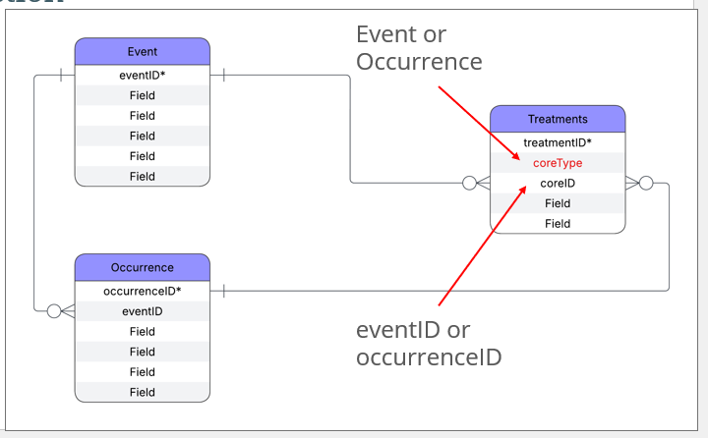

- Subclass Connection
Pros - treatments associated with a core entity e.g. event or occurrence.
This is the pattern that most closely resembles the DWC-Archive.
Trivial to validate in Darwin Core DP.
Cons - a lot of redundancy (repeated columns – when in a relational table system) if the same treatment is applied to multiple instances / multiple core entities.
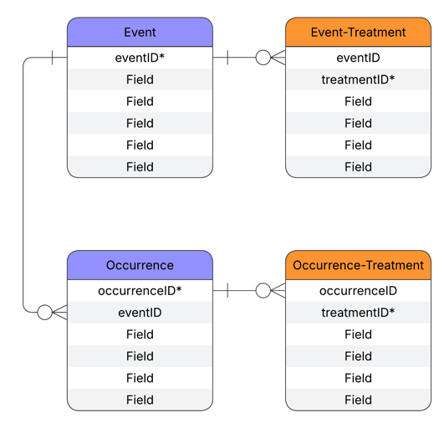
- Join Tables
Individual join tables for each class.
Pros – all treatments easily findable in one table, pattern that most closely resembles a relational database, reduces redundancy by using the relationship join rather than repeating the details of all re-used treatments
John – modelling wise this is awesome
Cons – John mentioned a sociotechnical con – adding multiple tables to the mix that wouldn’t otherwise be there – difficult for data aggregators to implement e.g. GBIF expressed resistance to this approach.

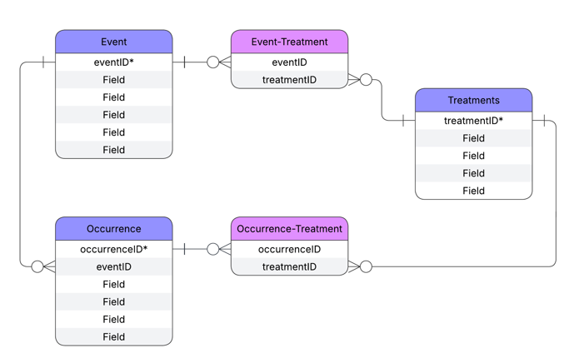
Combined Join Table
Pros – all treatments easily findable in one table, fewer join tables, reduces redundancy by using the relationship join rather than repeating the details of all re-used treatments
Cons – Rare pattern for DWC-DP – one precedent is Chronometric Age Reference – John mentioned another is the Identification class.

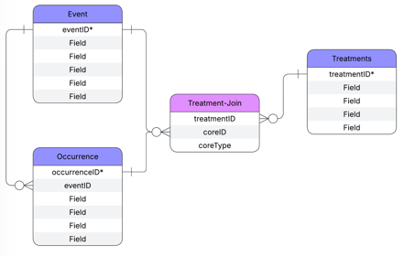
General Discussion
There was some discussion about potentially combining usagePolicy table with treatments at some stage. It was agreed that there was a difference between treatments and usagePolicy – the latter is more to do with licencing the raw data out and treatment is what has been done to the data to make it publicly available. They’re related but different concepts.

ACTION: It was agreed that using individual joining table for each class e.g. event, occurrence, agent etc etc would be the best way to proceed.

ACTION: Andrew to double-check with GBIF regarding the inclusion of multiple join tables and their resistance to this.

ACTION: The Task group to decide which additional fields if any need to be included in the join tables.

Next meeting

Next meeting will be the whole task group back together in about a month’

